|  |  |
| --- | --- |
| Project | Opencart |
| Tested by | Vishwa |
| Test Execution Date | dd-Mmm-yy |
| Test Cycle | 1 |
| Test Environment | localhost |
| Version, Release, Build Number | 1, 1, 1 |
| Test Scenario Number | TS0001 |
| Test Scenario | Register Functionality |
| Test Case ID | TC_RF_0011 |
| Test Case Description | Validate Registering an account by providing invalid Telephone number |
| Test Steps | 1. Click on 'My Account' drop-down menu  2. Click on 'Register' option  3. Enter new account details into all fields(First Name, Last Name, Email, Password, Password Confirm, Newsletter, privacy policy)  4. Key in the invalid Telephone number. <Refer to test data>  4. Click on 'Continue' button (ER-1) |
| Test Data | 98111111A$ |
| Expected Result | 1.Proper field level warning message should be displayed and account should not be created. |
| Actual Result | 1. Warning message is not getting displayed and an Account is getting created with the given invalid phone number |
| Test Result | Fail |
| Bug/Defect ID | OCD0001 |
| Steps to Reproduce | As given in Test Steps |

1. Click on 'My Account' drop-down menu

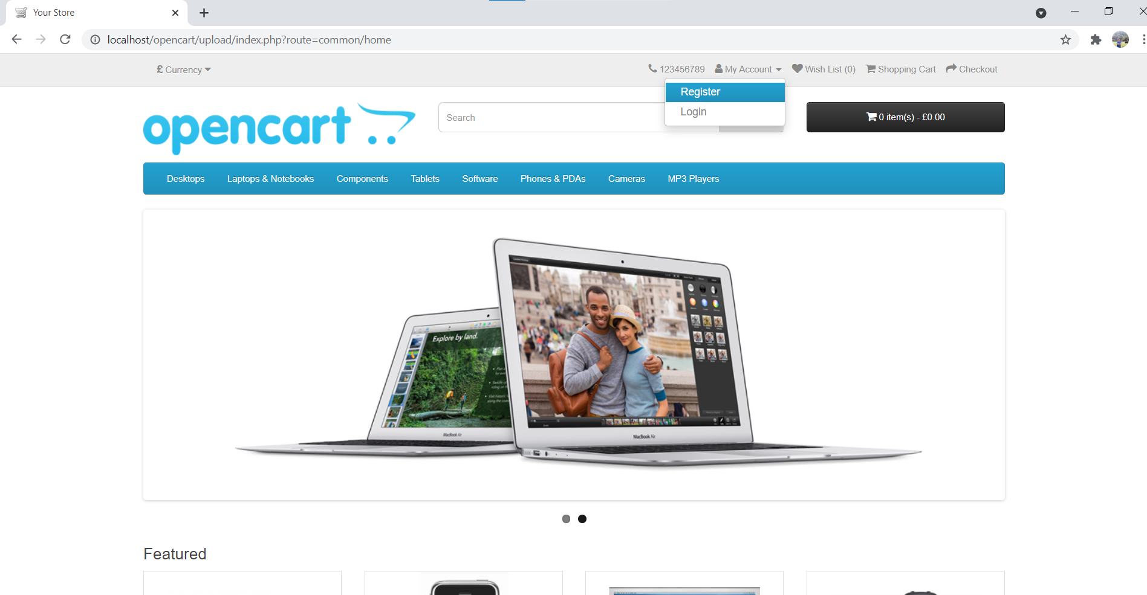

1. Click on 'Register' option

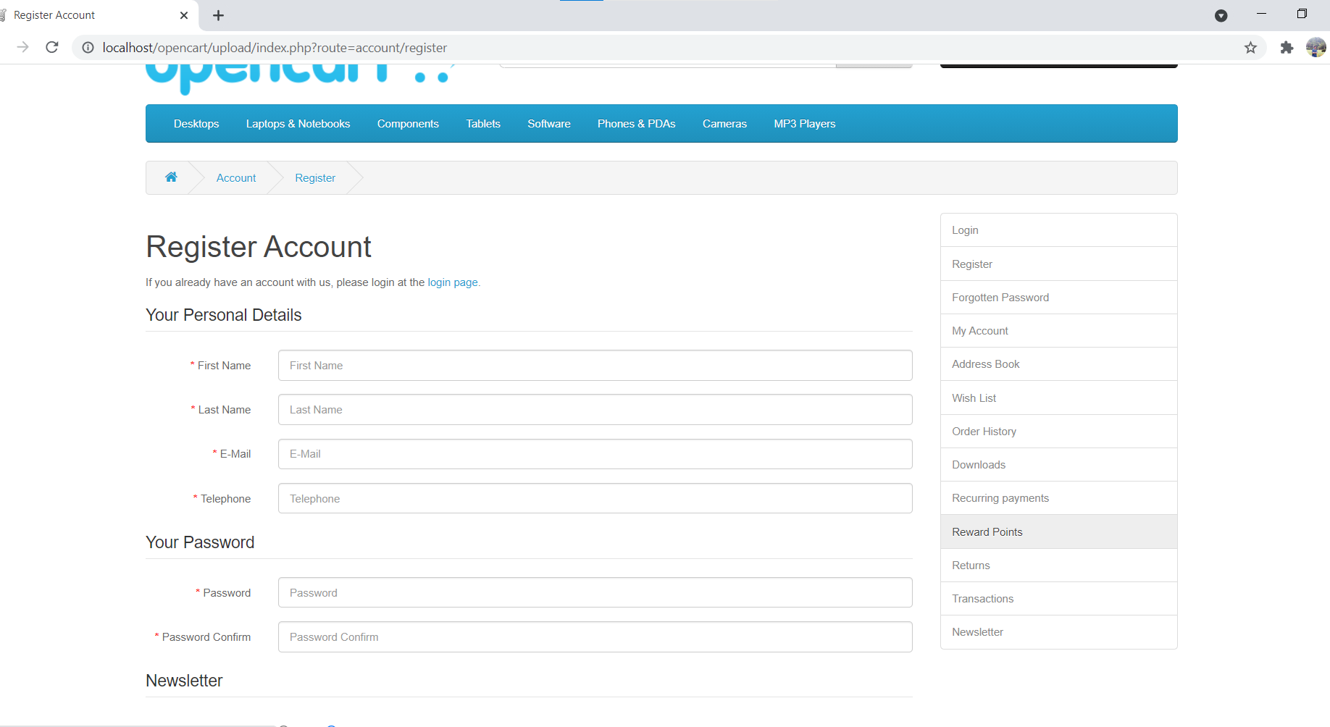

1. Enter new account details into all fields(First Name, Last Name, Email, Password, Password Confirm, Newsletter, privacy policy)

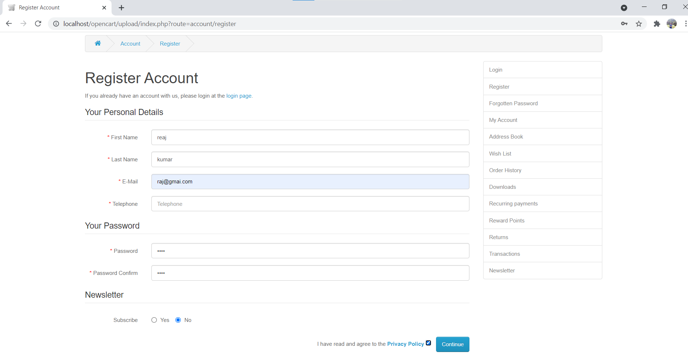

1. Key in the invalid Telephone number. (98111111A$)

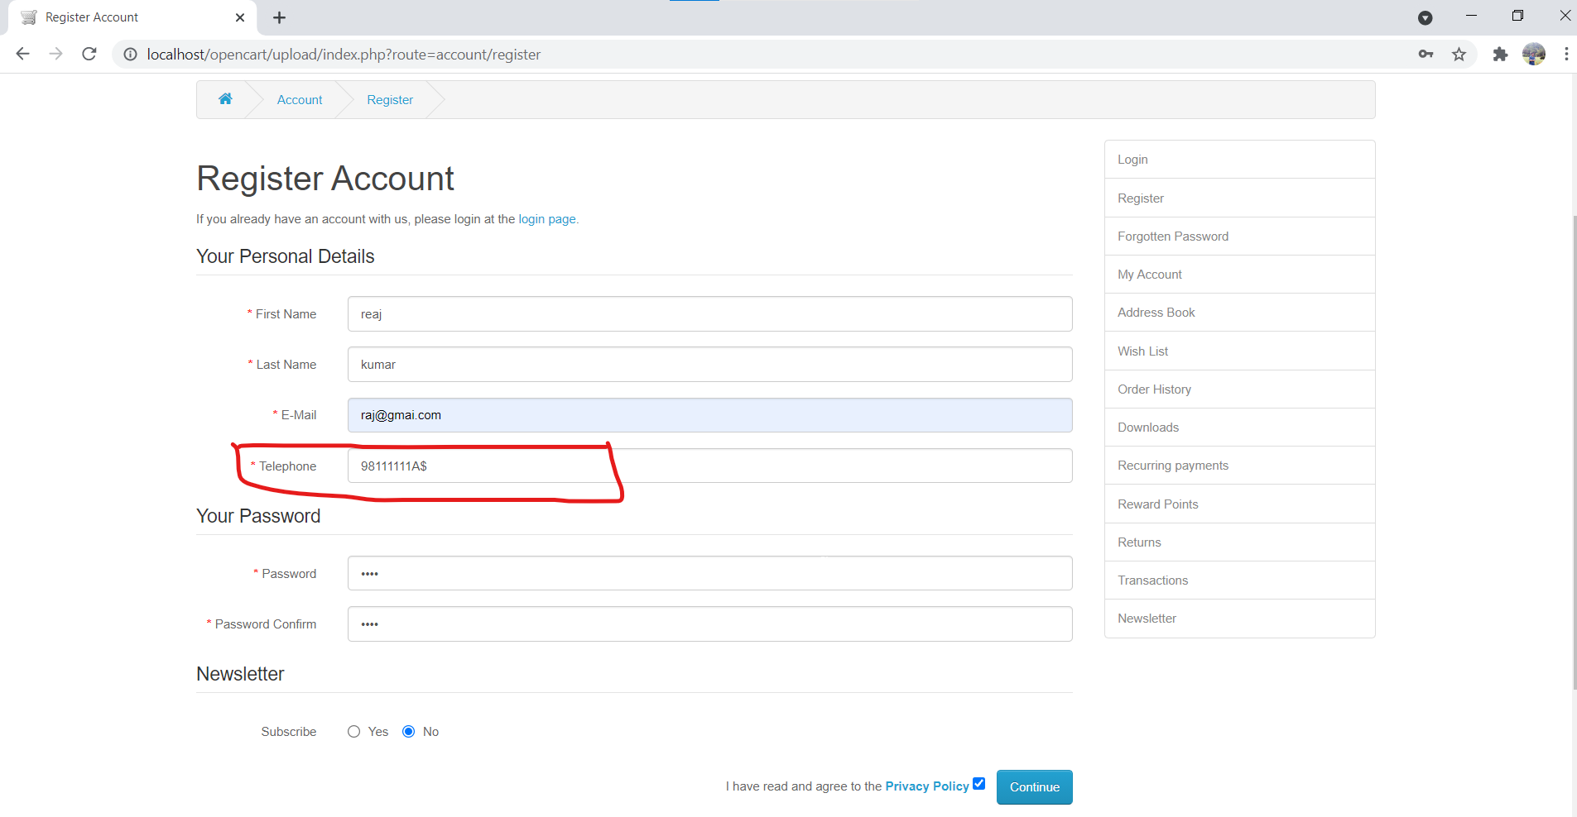

1. Click on 'Continue' button (ER-1)

